WEEK 5: NETWORK SCANNING AND ENUMERATION

Fig: 1 Nmap full network scanning
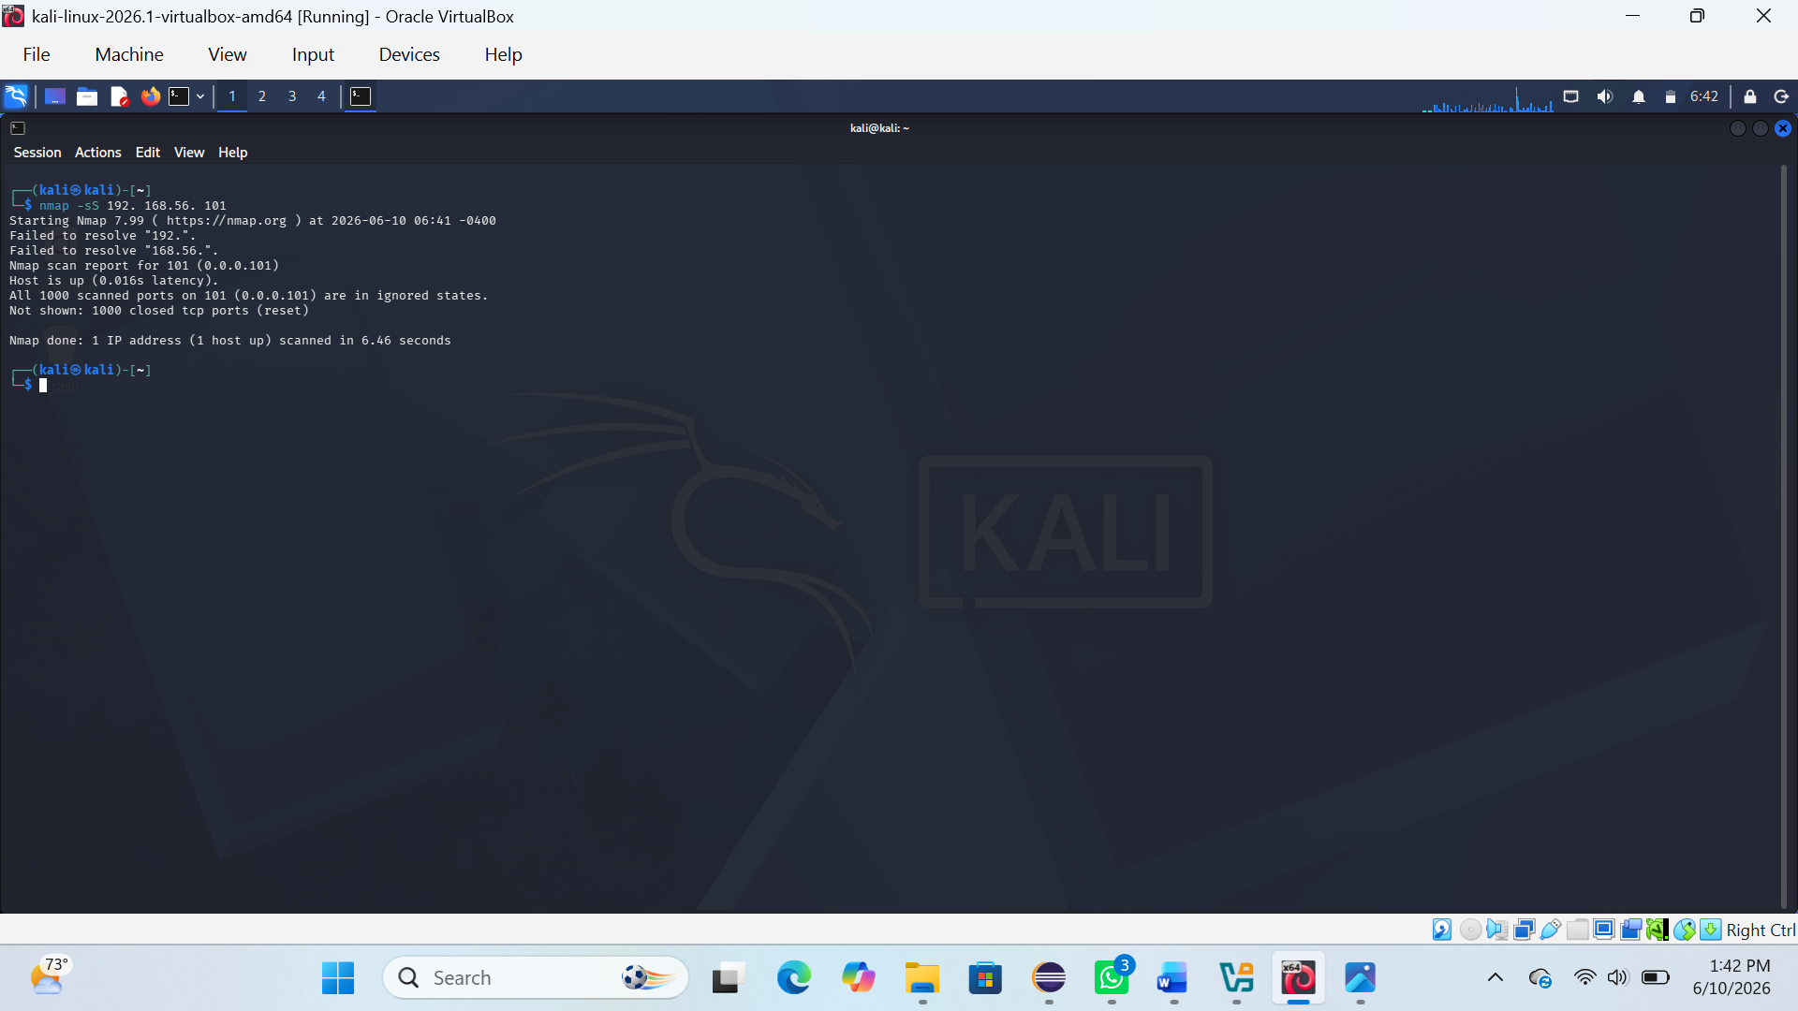

Fig 2: Scanning and service interaction
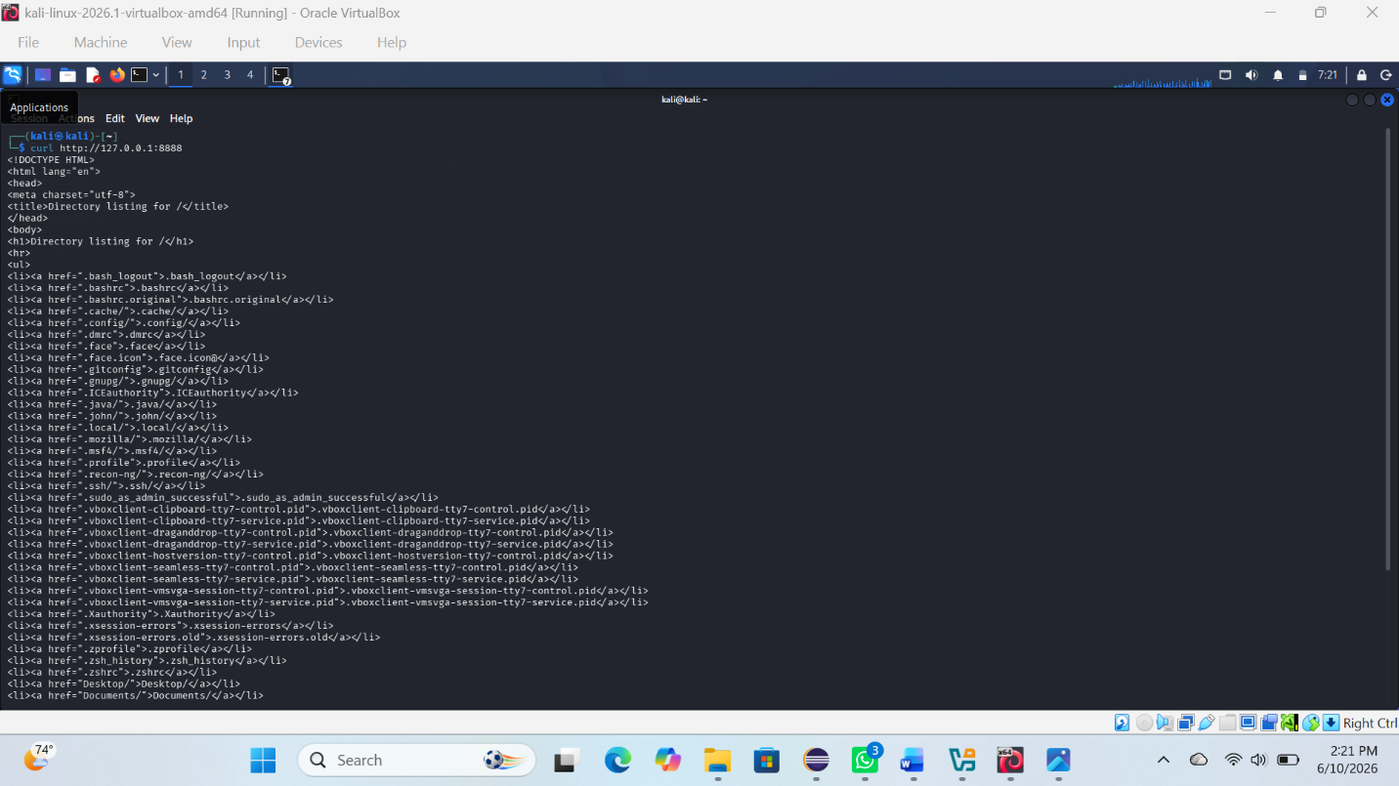
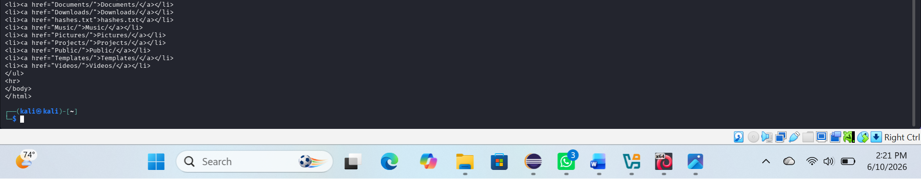

REFLECTION:
Week 5 focused on network scanning and traffic analysis using Nmap and Wireshark. It provided practical understanding of how active devices and services are identified, and how packet data reveals communication details within a network.

